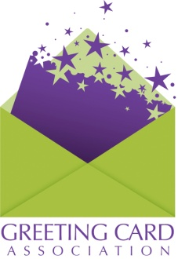
Annual Convention
Associates Tabletop Display, Welcome Bags & Associate Reception
Participation Form
Please submit this form, by Friday, August 24, to Meetings Associate, Maggie McDonnell.

Email: maggie@greetingcard.org Fax: 202.216.9646

Name:

Company:

Phone: Email:

Annual Convention

I will be attending the GCA Convention

I will NOT be attending the GCA Convention

AssociateS Display

I will submit a display of my company’s products/services for the GCA Convention.

I will NOT be submitting a display of my company’s products/services for the GCA Convention.

Welcome Bags

I will submit an item for the Welcome Bag.
My first choice is: My second choice is:

I will NOT be providing an item for the Welcome Bag.

AssociateS RECEPTION

Yes, I will be attending the Associate Reception and would like to contribute to the Associate
Reception at $250.00

Unfortunately I will not be able to attend the Associate Reception but would like to contribute to
the Associate Reception at $100.00

Payment Method (due with form)
I hearby authorize GCA to charge $__________
Credit Card: ___ MC ___ VISA ___ Discover ___ AMEX
Card Number: __________________________________________
Name or Company Name on Card: __________________________ Expiration Date: _______________
Signature: _____________________________________________

Email logo in both high resolution jpeg and eps format to maggie@greetingcard.org.

Please contact GCA Convention and Meetings Associate Maggie McDonnell at maggie@greetingcard.org or 202.216.9627 with any questions—
and we look forward to seeing you in Cleveland in September.

